

*IdentityIQ Accelerator Pack Password Synchronization*

Table of Contents

1. Overview 3

2. Password Source Target Mappings 3

3. Quick Link Change Password 3

4. Change Password Quick Link and Form Flow Chart 3

5. Password Interceptor 3

6. Forgot password 4

7. Password Expiration 4

8. Joiner/Rehire Password Synchronization 4

9. Password Synchronization Flow Chart 5

10. Manage Passwords 5

11. Batch Manage Passwords 5

**Document Revision History**

|  |  |  |  |  |
| --- | --- | --- | --- | --- |
| **Version** | **Date** | **Status** | **Author** | **Summary of Changes** |
| Version 1 | 3/2/18 |  | Rohit Gupta |  |
| Version 2 | 5/7/18 |  | Cathy Mallet | Minor edits |

## Overview

This feature synchronizes the password from source applications to the target applications. The mapping of source and target applications is done via the Self Service Onboarding Wizard or Administrative Wizard. Synchronization of passwords is not applied to service cubes.

## Password Source Target Mappings

There are two extended attributes on Application ObjectConfig that are used for password synchronization.

* **targetpasswordSync**: This attribute is used to a store comma-separated list of target applications. Any application that has this attribute populated is considered a source application
* **primarypasswordSyncaccounts**: This boolean attribute indicates whether to detect password change on the primary account or on all accounts of an application
* **isenterprisedirectory**: password will be changed via the "Change Password" quicklink for the application even though there is no source application set

## QuickLink Change Password

A new QuickLink “Change Password” is designed for the help desk and self service dynamic scopes. This QuickLink form takes an input password from either the help desk or a user and synchronizes that password from all source applications to the target applications. Change Password functionality is applied to applications that are onboarded with target applications for password synchronization or applications that are onboarded as “Enterprise Directory”.

## Change Password QuickLink and Form Flow Chart

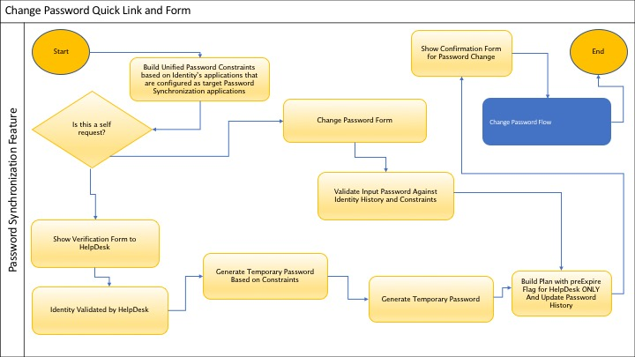

Please see [Password Synchronization Flow Chart](#Password Synchronization Flow Chart)

**Please Note:** The HelpDesk Verification Form Identity Attributes can be excluded using the Accelerator Pack QuickLink Global Definition

## Password Interceptor

A new “Workflow-Intercept-Password” workflow is designed to take the intercepted password from source applications and synchronize that password to target applications. This workflow ensures any password changed from IdentityIQ is not intercepted as a password change from interceptor. This stops the looping of the password change from IdentityIQ and Interceptor. This is done by storing the changed password in the Identity Password History during the “Change Password” process and checking that password during the interceptor workflow.

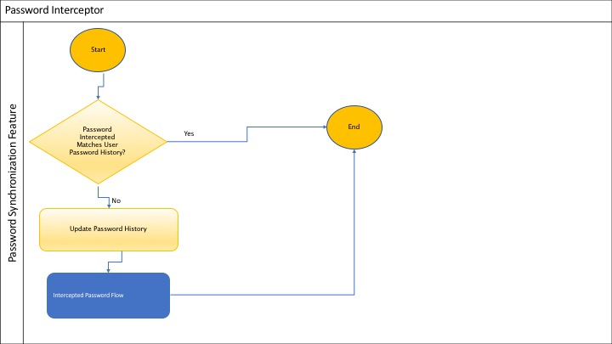

Please see [Password Synchronization Flow Chart](#Password Synchronization Flow Chart)

## Forgot password

This uses the Accelerator Pack workflow and does synchronize the passwords from source to target application accounts

Please see [Password Synchronization Flow Chart](#Password Synchronization Flow Chart)

## Password Expiration

This uses the Accelerator Pack workflow and does synchronize the passwords source to target application accounts

Please see [Password Synchronization Flow Chart](#Password Synchronization Flow Chart)

## Joiner/Rehire Password Synchronization

This uses the Accelerator Pack workflow and synchronizes the new joiner/rehire account source application password on the target application account. Before the provisioning in the workflow, the project plan is inspected, and the source application password value is copied from target application.

Please see [Password Synchronization Flow Chart](#Password Synchronization Flow Chart)

## Password Synchronization Flow Chart

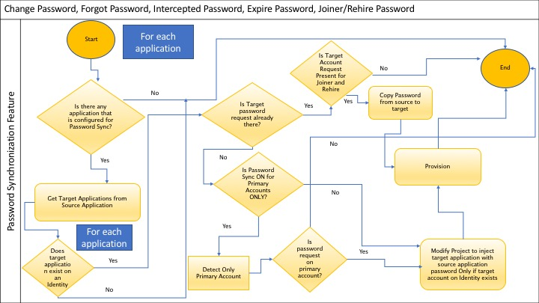

## Manage Passwords

This out of box QuickLink uses the Accelerator Pack workflow but doesn’t use any synchronization process. It just changes the password of the accounts that are selected on the manage passwords form.

## Batch Manage Passwords

Batch uses the Accelerator Pack workflow but doesn’t synchronize any password from source to target using extended attributes. It just changes the password of the accounts that are provided as an input from the csv file.